ON:

Policy# 1095083 11

FL screen REC - 351 , After the ? , e.g., 58th position.

New ratebook 'R' is reflected

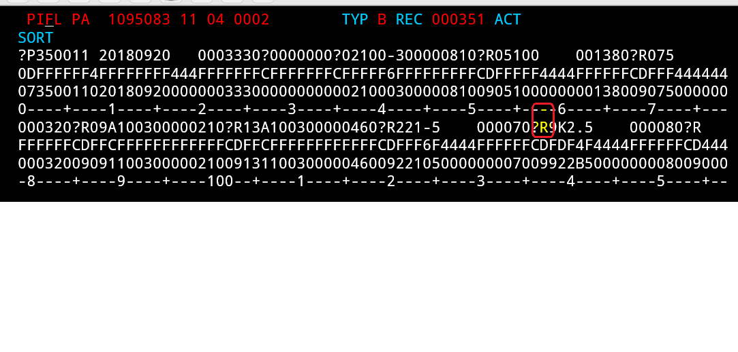

AFTER :

Policy# 1013836 12

FL screen REC - 351 – Letter after the ?, e.g., 58th position.

New rate book 'R' is reflected

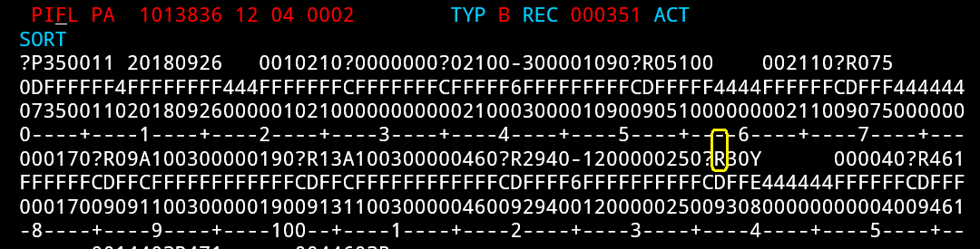

BEFORE:

Policy# 1000465 12

FL screen REC - 351 – Letter after the ?, e.g., 58th position.

Old ratebook 'Q' is reflected

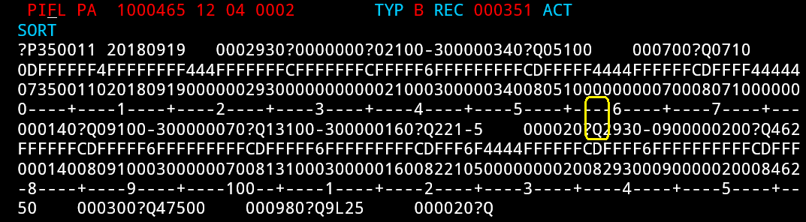

TEST CASE [Test Case 488930:](http://tfsprd:8080/tfs/DefaultCollection/Grange/_workitems/edit/488930?fullScreen=false)

